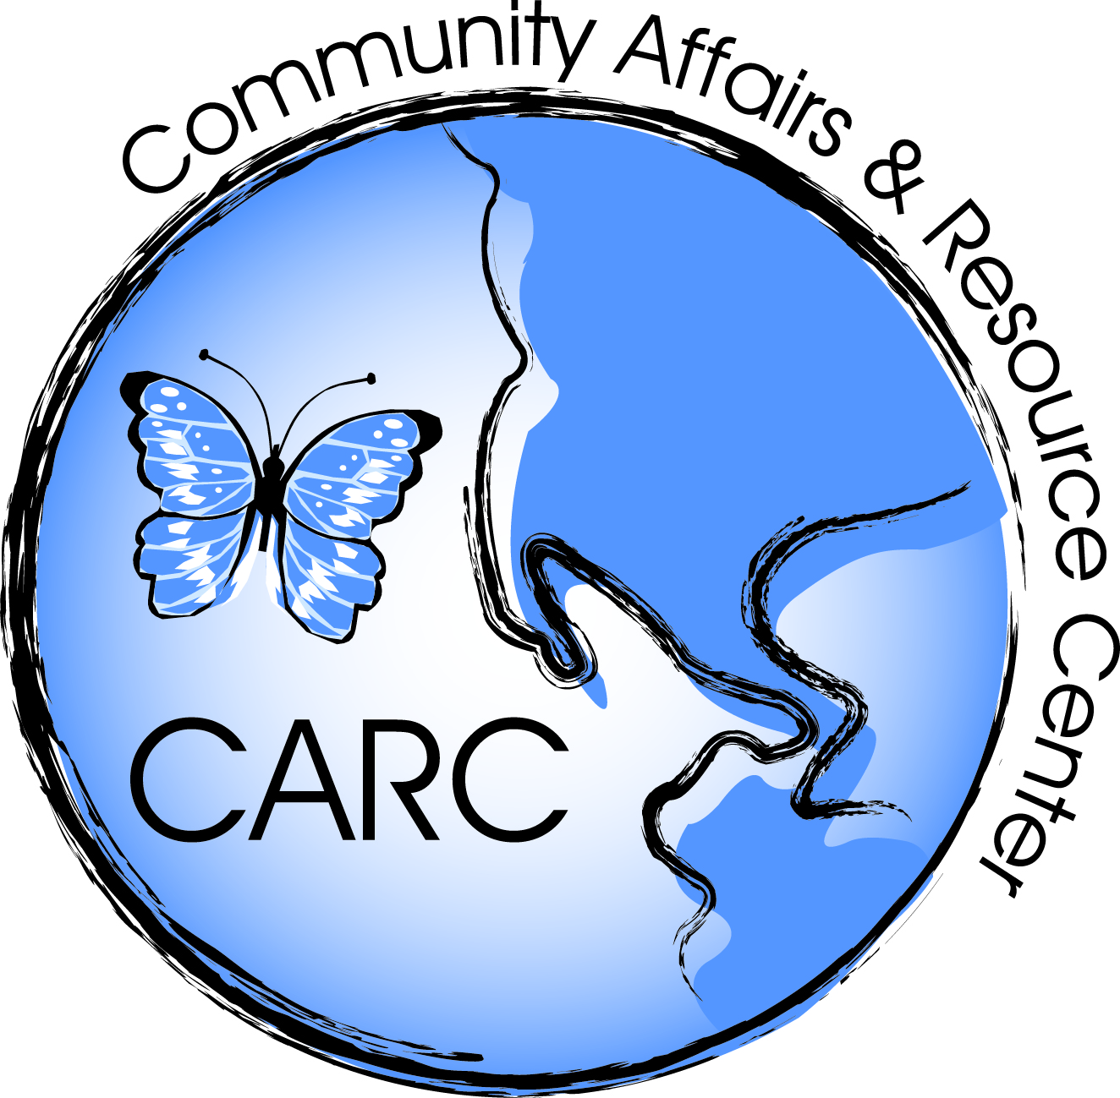  SIGNATORY PAGE | Community Affairs and Resource Center (CARC)  Request for Qualifications:  Lead-Safe Home Remediation Pilot Grant Program | RFQ #:  CARC  2017-02328-0065-00

Event | Date | Time
Bidder’s Question Due Date  (Refer to RFP Section 1.3.1 for more information.) | 2/9/2017 | 1:00 PM
Mandatory Pre-bid Conference | None | N/A
Mandatory Site Visit | None | N/A
Bid Submission Due Date  (Refer to RFP Section 1.3.2 for more information.) | 2/13/2017 | 1:00 PM
ALL PROPOSALS MUST BE SUBMITTED NO LATER THAN THE DATE AND TIME ADVERTISED FOR THIS BID TO:

Community Affairs and Resource Center
913 Sewall Ave.,
Asbury Park, New Jersey 07712
ATTN: LEAD-SAFE HOME REMEDIATION PILOT GRANT PROGRAM
Dates are subject to change. All changes will be emailed to all agencies currently certified by DCA for lead abatement.

TO BE FILLED OUT BY BIDDER:

FIRM NAME:_____________________________________________________________________________
ADDRESS:_______________________________________________________________________________
CITY: ___________________________________________ STATE: _______________ ZIP CODE: _______
BIDDER PHONE NO: ______________________________ BIDDER EMAIL: __________________________

FEDERAL EMPLOYER IDENTIFICATION NUMBER:______________________________________________

SIGNATURE OF BIDDER: ____________________________ DATE: ______________
PRINT NAME: ______________________________________TITLE: ______________

