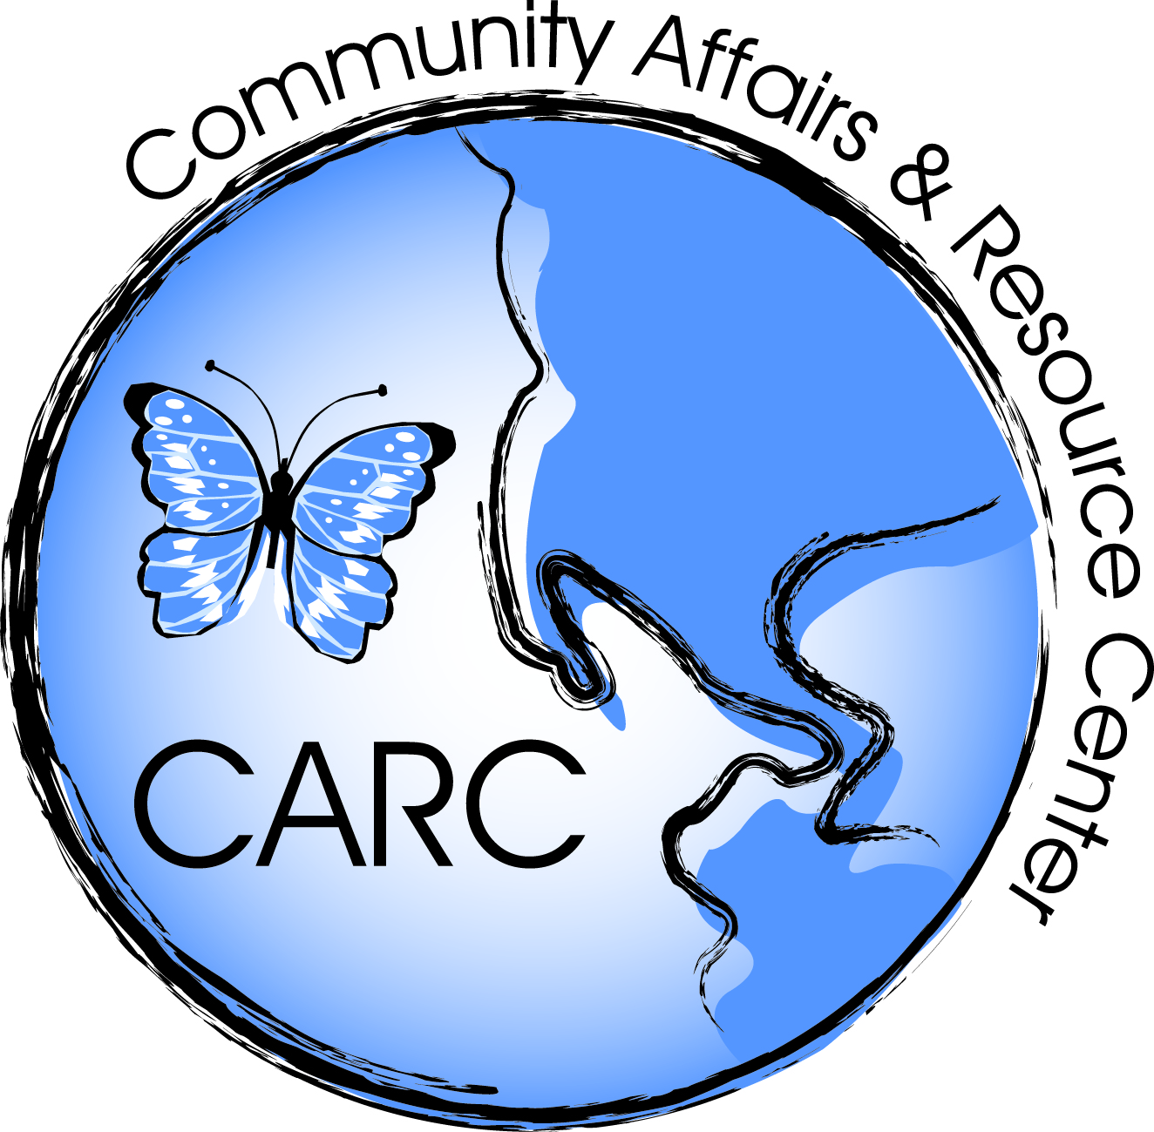

COMMUNITY AFFAIRS AND RESOURCE CENTER
LEAD REMEDIATION SERVICES
IN SUPPORT OF
THE LEAD-SAFE HOME REMEDIATION PILOT GRANT PROGRAM

Name of Contractor:

The Bidder must clearly check-off which regions will be serviced at the pricing provided:

Monmouth County
Ocean County
Atlantic County

Note: If a bidder wants to bid different pricing for separate regions, than a complete, new set of these schedules must be submitted for each region. Even if only one, or a few, unit prices are different, separate schedules must be submitted.
TYPE OF SERVICE | PRICE/ SQ FT | PRICE/ITEM
- LEAD REMEDIATION AND ABATEMENT SERVICES
Wet scrape and paint stabilization of  - Wall  - Floor  - Ceiling  - Window  - Well  - Sill  - Case  - Stair  - Stringer  - Riser  - Door  - Molding  - Jamb  - Baseboard  - Other | $  $  $  $  $  $  $  $  $  $  $  $  $  $  $ | $  $  $  $  $  $  $  $  $  $  $  $  $  $  $
(Aluminum) enclosure of  - Window  - Sill  - Sash  - Jamb  - Wells  - Case  - Door  - Molding  - Jamb  - Soffits  - Other  Vinyl siding enclosure, exterior walls | $  $  $  $  $  $  $  $  $  $  $  $ | $  $  $  $  $  $  $  $  $  $  $  $
Wet scrape to bear substrate and repaint  - Walls  - Floor  - Ceiling  - Window  - Well  - Sill  - Case  - Stairs  - Stringer  - Riser  - Door  - Molding  - Jamb  - Baseboard  - Other | $  $  $  $  $  $  $  $  $  $  $  $  $  $  $ | $  $  $  $  $  $  $  $  $  $  $  $  $  $  $
Removal and replacement of  - Window  - Well  - Sill  - Case  - Door  - Molding  - Jamb  - Baseboard  - Other | $  $  $  $  $  $  $  $  $ | $  $  $  $  $  $  $  $  $
- MAINTENANCE PLAN | PRICE/ SQ FT | PRICE/ITEM
Maintenance plan for completed project | $ | $

