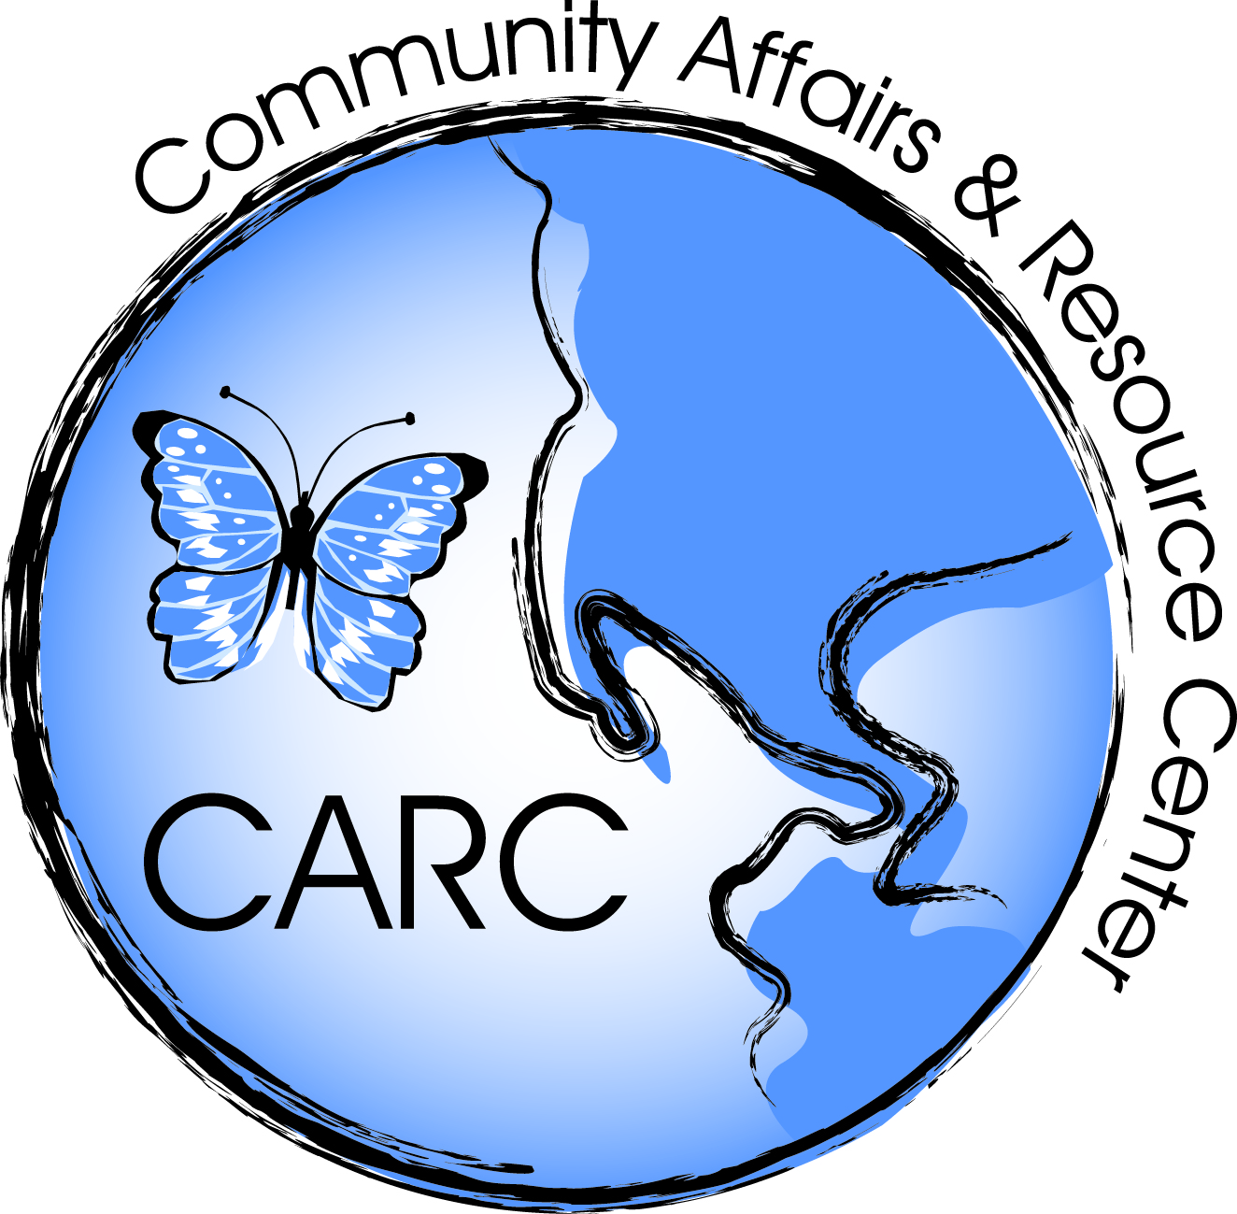
Community Affairs and Resource Center
Request for Qualifications Checklist

RFQ #: CARC 2017-02328-0065-00

Contractor: Telephone Number:

This checklist was created as a guide to assist bidders in preparing a complete and responsive proposal. It is only advisory in nature.
It is the bidder’s responsibility to ensure that all requirements of the RFQ have been met.

SECTION I: FORMS THAT MUST BE COMPLETED and SUBMITTED WITH Proposal:

 | 4.4.1.1 | Signatory Page with original signatures
 | 4.4.1.2 | Ownership Disclosure Form
 | 4.4.1.3 | Disclosure of Investigations and Other Actions Involving Bidder
 | 4.4.3.4 | Disclosure of Investment Activities in Iran
 | 4.4.1.5 | Notice of Intent to Subcontract & Utilization Form (if applicable)
 | 4.4.2.1 | N.J. Business Registration Certificate*
 | 4.4.2.2 | Small Business Set-Aside Contracts: Registration with NJ Economic Growth and Tourism, Commission (Commerce)
SECTION I: FORMS THAT MUST BE COMPLETED and SUBMITTED BEFORE Contract Award
 | 4.4.3.1 | MacBride Principles and Northern Ireland Act of 1989
 | 4.4.3.2 | Affirmative Action Employee Information Report/New Jersey Affirmative Action Certificate
SECTION II: TECHNICAL PROPOSAL
 | 4.4.4 | Bidder/Contractor Qualifications; Narrative: All information requested as Described in Lead Services per BID Instruction Packet; Including Lead Status Certificates
SECTION III: ORGANIZATIONAL SUPPORT AND EXPERIENCE
 | 4.4.5. | Information relating to organization: organizational chart (contract specific and entire firm), personnel with resumes; references evidencing the bidder's qualifications and capabilities to perform the services required by this RFP; financial capability, subcontractors
SECTION IV: COST PROPOSAL
 | 4.4.6 | Pricing using format of sample/template located on CARC site: www.carcnj.org

Bidders must ensure that all requirements of the RFQ have been met as the RFQ language supersedes this advisory checklist in the event of an error or omission.

